System Simulation Project 2 Write-Up

Daniel Walpole

Task 1: Organization of data

For the observation of the real system of McDonalds, I decided to use around 100 values for each of the four stations to get a semi-accurate reading for each one. I took each of these values and then organized them in excel. I then normalized them to the time value in seconds to see the elapsing of time. I could then use excel to make a histogram with this data.

Here are the results:

Arrivals

Hill_Somayire

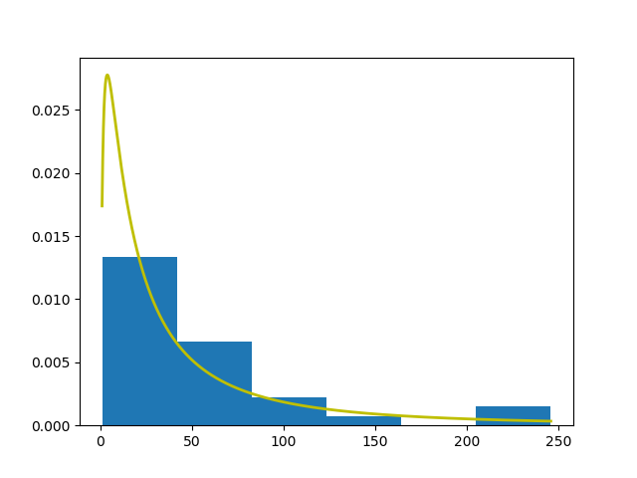

The yellow is a lognormal distribution with a mean of 0.8919192 minutes and a standard deviation of 0.976957803 minutes. The data has 33 data points and 6 bins.

The data is also showing the difference in arrival times in seconds.

This distribution was chosen because as the data showed that most arrival times were separated by less time rather than more time and matched quite well with the curve.

Fitness test: .458

Place Order

Hill_Somayire

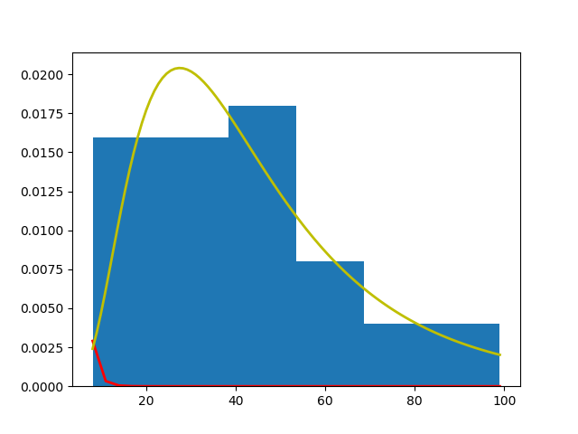

Yellow lognormal distribution has a mean of 0.6722166 minutes and a standard deviation of 0.38146434466 minutes. There are 33 data points put into 6 bins.

This distribution was chosen because it was more populated at the beginning of the curve for time spent to order. Meaning that as people ordered it was usually quite quick with most being done in around 45 seconds.

Fitness Test: .413

Pay

Hill_Somayire

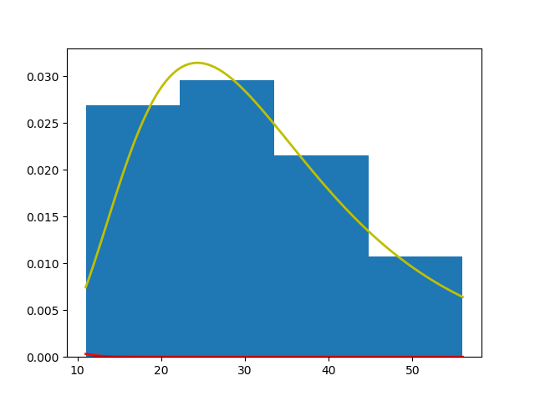

Yellow lognormal distribution has a mean of 0.498989899 minutes and a standard deviation of 0.204121567833 minutes. There are 33 data points put into 4 bins.

This distribution was chosen for the same reason as the order, as the time for ordering was also more centralized at the beginning of the distribution. This however is the worst of the distributions and should be looked at like a logarithmic

Fitness Test: .427

Pickup

Hill_Somayire

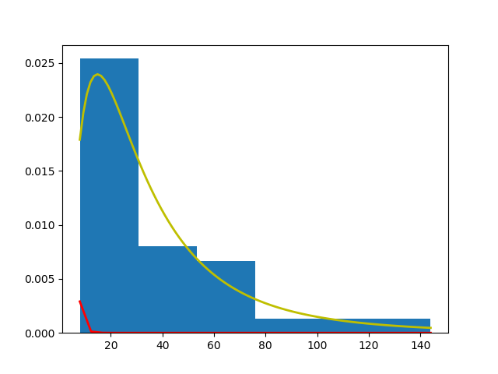

Yellow lognormal distribution has a mean of 0.430006791166 minutes and a standard deviation of 0.16948815833 minutes. There are 33 data points put into 6 bins.

Fitness Test: .362

Task 2: Simulation results:

From the test of the simulation where I estimated the functions and arrivals would be lognormal with the following means and standard deviation matching the real systems data. Here are the results:

Arrival:

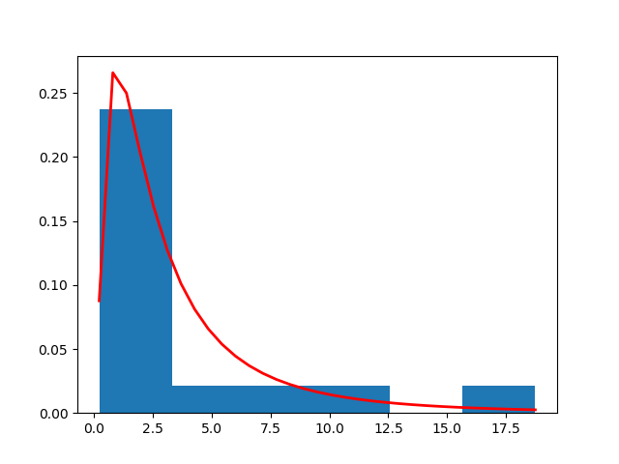

Mean: 4.037242273

Standard Deviation: 5.173040541

Order:

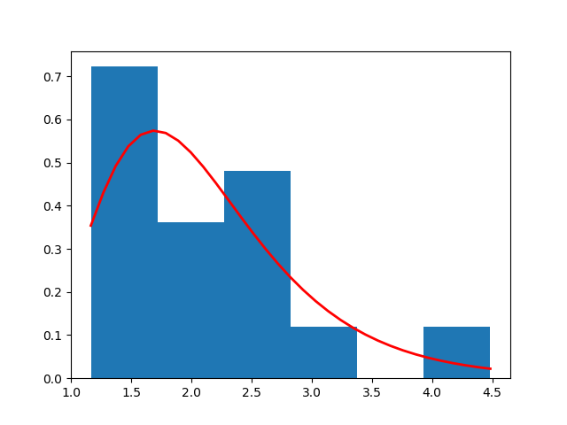

Mean:2.102277794

Standard Deviation: 0.870160442

Payment:

Mean:1.719343948

Standard Deviation:0.28320253

Pickup:

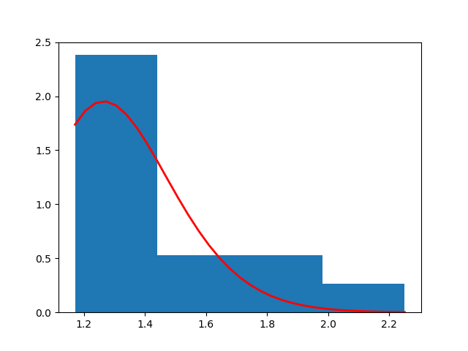

Mean:1.461733592

Standard Deviation: 0.307513801

The distributions simulated all provided an output similar, to that of the real system counterpart. I would also say that they are similar but not the same regarding accuracy. The means of all the simulation is all much greater than that of the real system which lead to fewer customers being seen in the simulation. This could be due to my coding or the seed I had chosen.

Section 3: Thoughts and Improvements:

From a point of view examining this simulation in comparison to the previous simulation I feel as if we should have addressed the cooking aspect of this. Then there is the aspect of the data collection. This data will never be as good as if it was from the source and the next time a project like this would be given I would recommend talking to the owner of the establishment and asking for the data first hand so the simulation can be as accurate as can be from the accumulated data.

As for statistical analysis I would recommend working with some people who are good at math. But in all seriousness, I would say that having a large enough data set that is within a limit and has already been pruned of all bad results. There should have also been a maximum error allowed.